**Step One**: **Research for International Travel Website**: Below is the information that will be needed for your first Independent Website. You will select a country or major city within a country to create your site for. **NOTE:** I am not assigning countries but this must be **original research** – not recycled work from a former project in another class. If found to be the case you will start over with an assigned country /city. You can focus on just one city in a county. **Example**: Paris, France versus all of France. Some students find it easier to focus on a major city. Your choice!   
 **NOTE**: International means **not** the United States.

1. Make a new folder in your e-commerce folder. Save as Last, First, International Website
2. Save this document in the new folder. You will also save all notepad pages and images in this folder.
3. Check off on this sheet as you gather each section of information below. Do not check off if not complete! Gathering all information first will save you an incredible amount of time when you start to construct the site.
4. **List the website and url’s that you are gathering information from. Will need to provide when turn in site.**

**Country and/or Major City (Cities) in Country Selected: London, England_____________________________________   
Note: Many students find it is easier to focus on one or two major cities in a country versus the whole country.**

|  |  |
| --- | --- |
| **Information to gather: Be sure it is complete! Saves so much time to have it all first. NOTE!!! YOU are not making a website yet! ONLY gathering information – will storyboard next!!** | **Check Off If Complete** |
| **Facts** - population, time change, climate, language, how to say (basic phrases words in the native language), travel restrictions, government, etc. (If doing one city be specific for that city) | **x** |
| The **best time** of year to visit and why | x |
| **Local inns and hotels** - **minimum of four** with information, pricing, and image(s) | **x** |
| The best way to get around the city/ country to sight see **(transportation options for tourists)** | x |
| At least **top four places of interest to visit**– with detailed description and image(s)  **IMPORTANT NOTE**: These are specific places of interest to visit not a city! Historical landmarks, museums, ruins, castles, etc. Information and images are for this specific place to visit. Think what a tourist would not want to miss seeing when they visit your major city or country. | x |
| **Historical mini lesson** – Four paragraphs with solid information and images |  |
| **Cultural info and differences** **(min of 5)** What would be rude? Unacceptable? Expected? Gender? | **x** |
| Information on the **type and exchange of local currency**. Do they deal with credit cards? | x |
| Information about the **local cuisine with descriptions** of dishes and **images** (min. 4 dishes)   **Note**: N**ot restaurants** | X |
| A **f**requently **a**sked **q**uestion**s** page with important information travelers would want. Minimum of five questions. Will be a separate page. |  |
| A **quality map** of the destination – image. Be sure it is not blurry! | x |

**Population:**

* 9 million

**Time Change:**

* 5 hours ahead of EST time zone

**Climate:**

* Cool winters, warm summers, precipitation all year round

**Language:**

* English

**Government:**

* The Prime Minister is the leader of the government in the United Kingdom
* The Cabinet meets every week to discuss issues for the government
  + Comprised of 20 ministers
* The Civil Service does administrative work in the government and provides public services
* The Government in the UK decides how the country is run and managed, where public funds go, and how to deliver public services
* Parliament exists to monitor the government and represent the people’s best interest as well as pass legislation and set taxes.
* <https://www.gov.uk/government/how-government-works>

**Best Time of Year to Visit:**

* The best time of year to visit London is in either the spring or fall because those are the most mild weathered times of year.

**Local Hotels (min 4):**

* Point A Hotel
  + $40 a night
  + Free wifi, non-smoking, not pet friendly
  + Must have method of payment and ID proving above the age of 18 at check-in
  + Rated 8.4/10.0
  + A sign on the side of a building

    Description automatically generated
  + <https://www.hotels.com/ho406287/?pa=5&tab=description&ZSX=0&SYE=3&q-room-0-children=0&q-room-0-adults=1>
* Hampton by Hilton
  + $78 a night
  + Free wifi, non-smoking, not pet friendly, free breakfast, laundry service, fitness center
  + Must have method of payment and ID proving above the age of 18 at check-in
  + Rated 8.8/10.0
  + 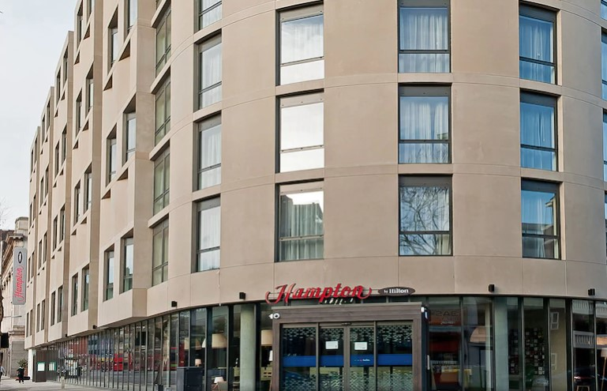
  + <https://www.hotels.com/ho448661/?pa=6&tab=description&ZSX=0&SYE=3&q-room-0-children=0&q-room-0-adults=1>
* The Exhibitionist Hotel
  + $74 a night
  + Free wifi, non-smoking, not pet friendly, parking available, restaurant, laundry service
  + Must have method of payment and ID proving above the age of 18 at check-in
  + Rated 8.6/10.0
  + 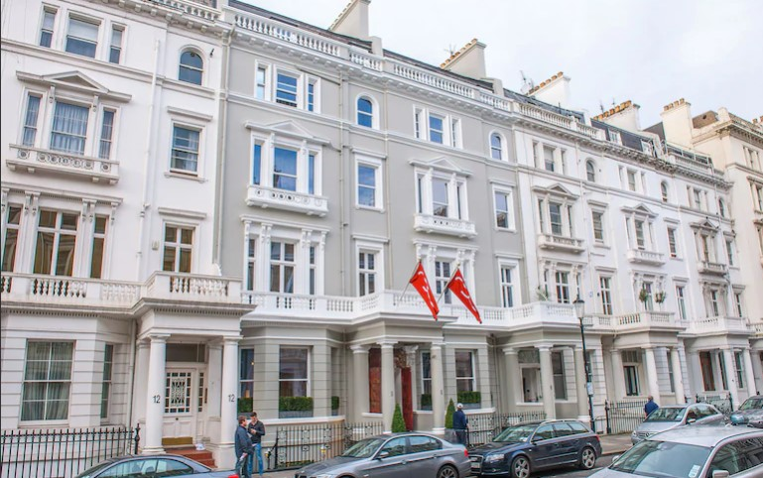
  + <https://www.hotels.com/ho119903/?pa=14&tab=description&ZSX=0&SYE=3&q-room-0-children=0&q-room-0-adults=1>
* Cleveland Hotel
  + $42 a night
  + Free wifi, non-smoking, not pet friendly, daily housekeeping, laundry service
  + Must have method of payment and ID proving above the age of 18 at check-in
  + Rated 8.4/10.0
  + 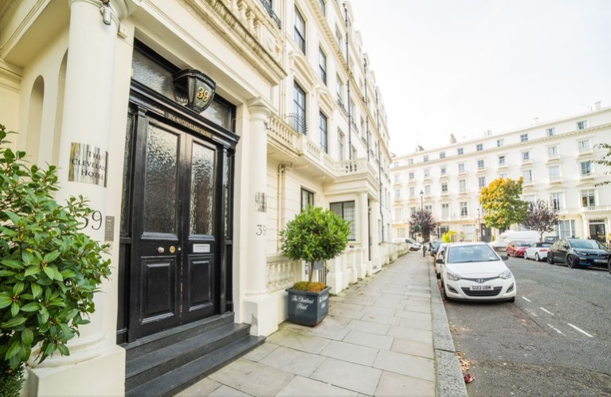
  + <https://www.hotels.com/ho298076/?pa=26&tab=description&ZSX=0&SYE=3&q-room-0-children=0&q-room-0-adults=1>

**Transportation Options for Tourists:**

* The main modes of transportation for tourists in London are public buses, taxies, and the London Underground rail network
  + Public Buses-
    - Only takes contactless payment (no cash)
    - Once you’ve paid you can take unlimited buses for free within the hour of payment
    - Buses are 24-hr
    - Buses offer tours of London
    - <https://www.visitlondon.com/traveller-information/getting-around-london/london-bus>
  + Taxis-
    - Taxies are metered and have a minimum fee of £3.20
    - Taxies are available for hire from the street or by telephone
    - <https://www.visitlondon.com/traveller-information/getting-around-london/taxis>
  + The London Underground-
    - Also called “the Tube”
    - Riding fare depends on distance traveled and time of day
    - Usually runs from 5 a.m. to midnight
    - A single journey is around £2.00-£5.00
    - <https://www.visitlondon.com/traveller-information/getting-around-london/london-tube>

**4 Places to Visit:**

* Big Ben
  + Clock tower at the Houses of Parliament
  + Built in 1844
  + 315 feet tall
  + 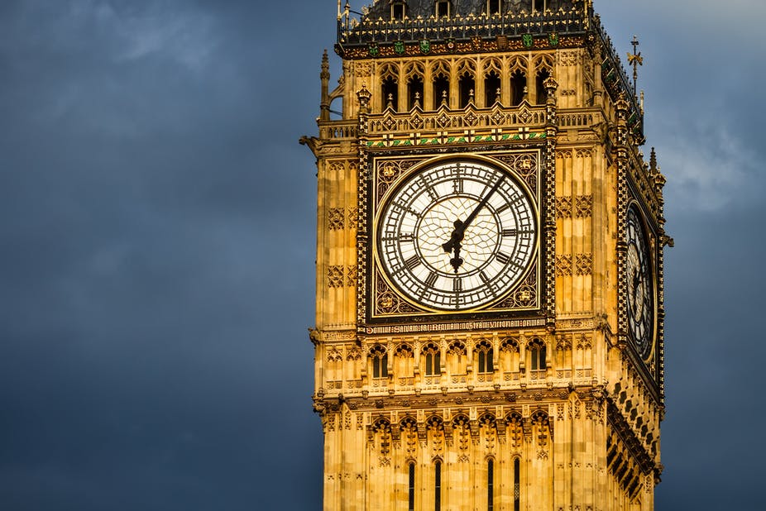
* London Eye
  + Ferris wheel
  + Built in 1999
  + 443 feet tall
  + Was built to memorialize the millennium as it came to an end
  + 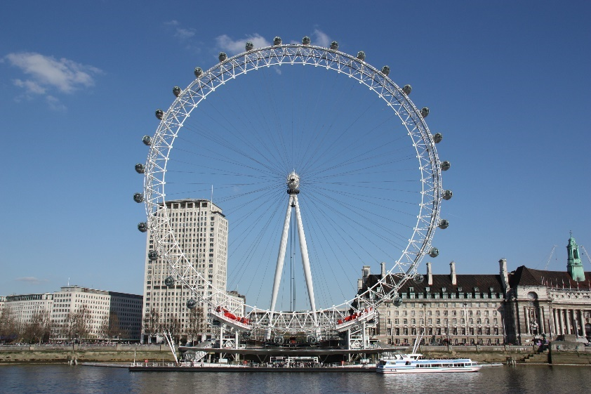
* Tower Bridge
  + Built between 1886 and 1894
  + Is a suspension bridge over River Thames
  + Has 2 towers connected by 2 walkways
  + 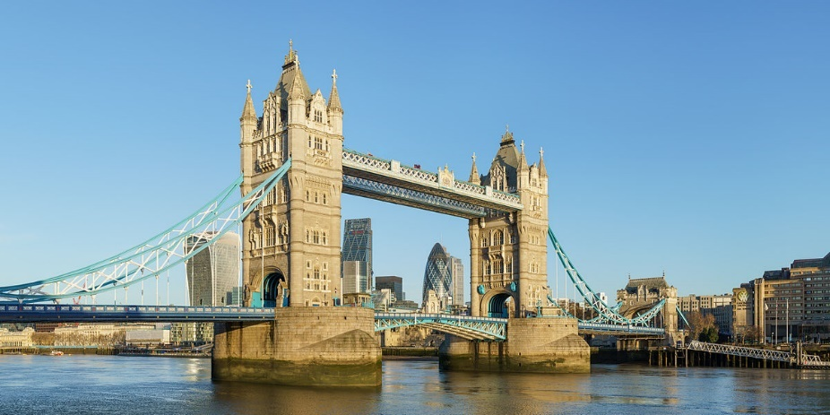
* Hyde Park
  + One of London’s 8 royal parks
  + Covers 350 acres
  + 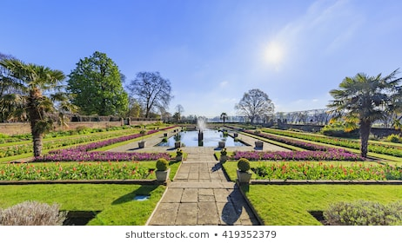

**Cultural Info/Differences (min 5):**

* Americans are considered more outspoken and this can appear as rude to those in the UK because they are generally more reserved.
* In England drinking is ingrained into social events much more than in the US
* When eating out, portion sizes in the UK are smaller than in the US
* In the UK, parking is not always available and often when it is you have to pay for it which is very different from the US where we very rarely have to pay for parking
* While American football is the most popular sport in the US, soccer (or football in the UK) is popular in England

**Type and Exchange of Currency:**

* The type of currency in England is pounds
* £1=$1.32
* $1=£0.76
* Cash and credit cards are both commonly used, but cashless payment Is encouraged. Some transactions are more expensive when using cash.

**Local Cuisine (min 4):**

* Full English Breakfast
  + This dish usually consists of sausages, eggs, mushrooms, tomatoes, blood pudding, potatoes, and toast
  + 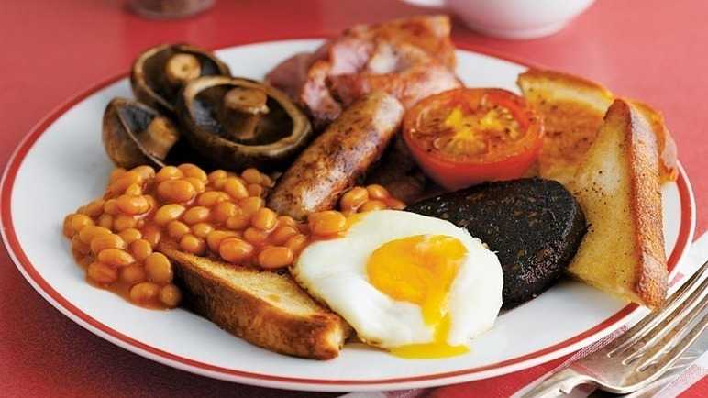
* Eton Mess
  + A dessert that is a mix of crushed merengue, cream, and strawberries
  + 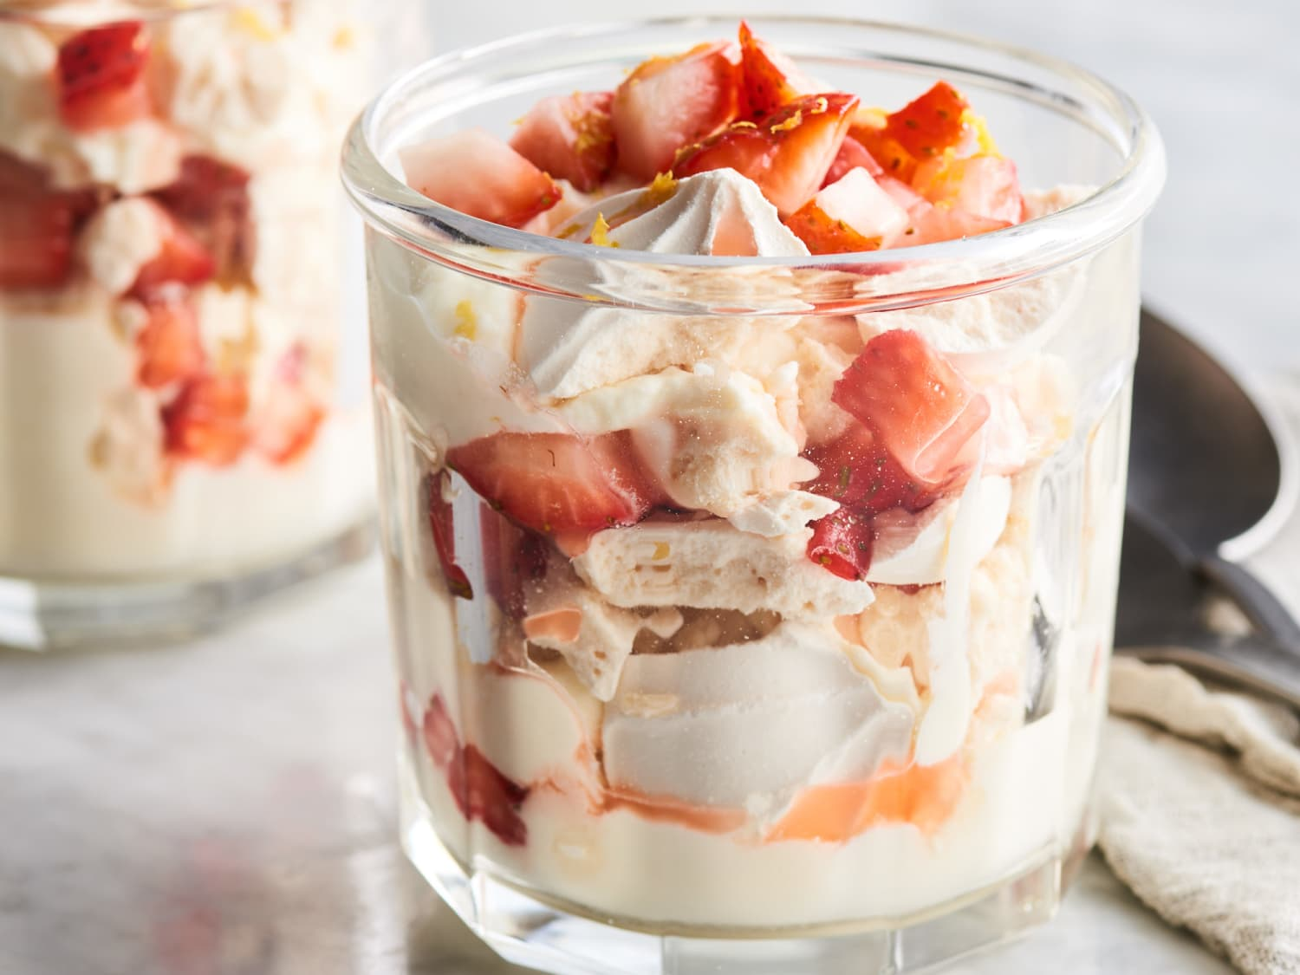
* Sticky Toffee Pudding
  + A dish made of sponge cake stuffed with raisins or dates soaked in a toffee sauce and served with custard or ice cream
  + 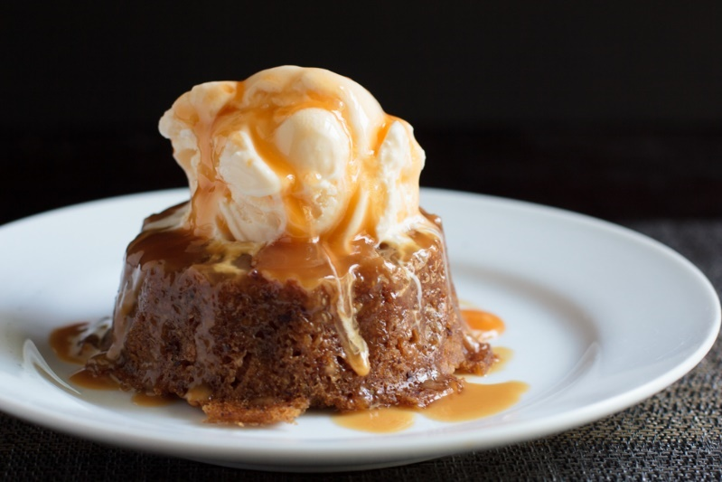
* Beef Wellington
  + This dish consists of a filet steak wrapped in puff pastry and cooked
  + 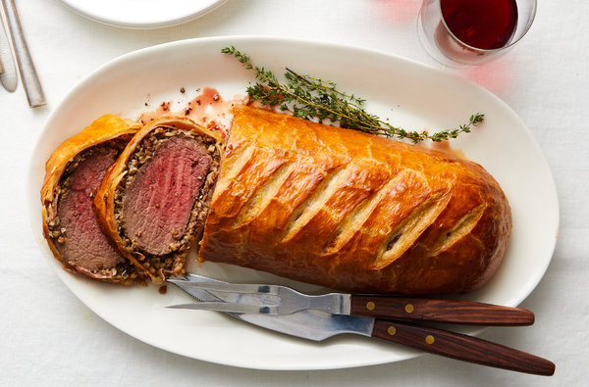

**Quality Map:**

* 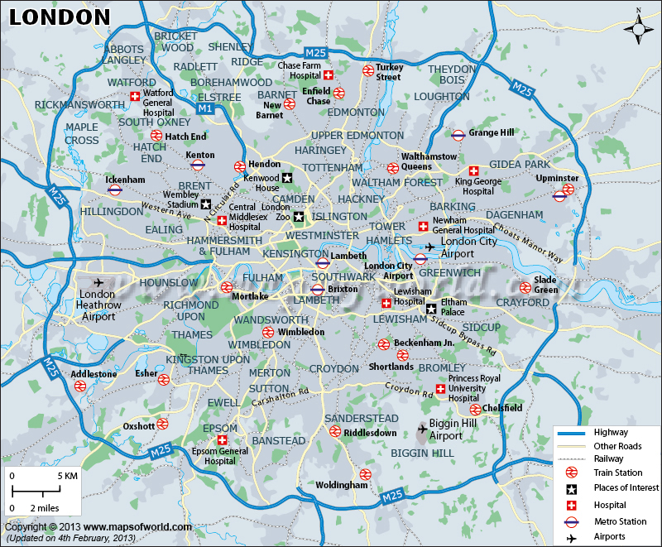
* <https://www.mapsofworld.com/united-kingdom/london-city-map.html>